**DFIELD TUTORIAL**

DFIELD is an interactive tool for studying single first order differential equations. To use it you must have MATLAB 4.1 or newer. This will NOT work on trex.

**Note:** If you want a hard copy of this (so as not to tie up a printer) it is available at Cards and Copies in the SUB.

* [Getting started](http://www.math.montana.edu/%7Eumsfjdoc/dfieldtut.html" \l "starting)
* [Entering the equation](http://www.math.montana.edu/%7Eumsfjdoc/dfieldtut.html#equations)
* [The Slope field](http://www.math.montana.edu/%7Eumsfjdoc/dfieldtut.html#slope)
* [Graphing numerical solutions](http://www.math.montana.edu/%7Eumsfjdoc/dfieldtut.html#solutions)
* [Other options](http://www.math.montana.edu/%7Eumsfjdoc/dfieldtut.html#options)
* [Graphing while dfield is open](http://www.math.montana.edu/%7Eumsfjdoc/dfieldtut.html#mgraphs)
* [Graphing on the dfield display window](http://www.math.montana.edu/%7Eumsfjdoc/dfieldtut.html" \l "dfgraphs)

**Getting started**

To start dfield you must first fire up MATLAB.

**Note**:

For DFIELD to work properly, you must make sure

that you are in a directory that you can write to.

There should be nothing to do if you are working on

the machines in Reid or Wilson. To check it anyway

the pwd command in MATLAB tells you what directory

you are in:

>>pwd

ans = D:\MATLAB\BIN

If this is what you see and you are a PC in Reid or Wilson you

should cd to another directory that you can write to, for

example:

>>cd c:\

[I:\ARCHIVOS MATLAB\Archivos HTML\DFIELD TUTORIAL_archivos\top.gif](http://www.math.montana.edu/~umsfjdoc/dfieldtut.html#top)

**Entering the equation**

When DFIELD is executed, a DFIELD Setup window is opened. The user may enter the differential equation and specify a display window using the interactive controls in the Setup window. This window should look like this:

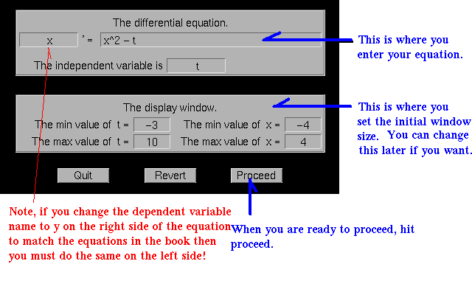

[I:\ARCHIVOS MATLAB\Archivos HTML\DFIELD TUTORIAL_archivos\top.gif](http://www.math.montana.edu/~umsfjdoc/dfieldtut.html#top)

**The Slope field**

When the Proceed button is pressed on the Setup window, the DF Display window is opened. At first this window displays a direction line field for the differential equation. Which should look like this:

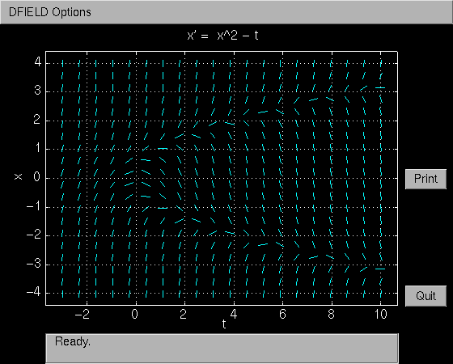

If the direction field is missing then there most likely is an error message in the matlab window like: **>>error fprintf**

The problem is that you do not have write access to the directory that you are. See the [**NOTE**](http://www.math.montana.edu/%7Eumsfjdoc/dfieldtut.html#error) above about changing directories within MATLAB.

[I:\ARCHIVOS MATLAB\Archivos HTML\DFIELD TUTORIAL_archivos\top.gif](http://www.math.montana.edu/~umsfjdoc/dfieldtut.html#top)

**Graphing solutions**

When the mouse button is depressed in the DFIELD Display window, the solution to the differential equation with that initial condition is calculated and plotted.

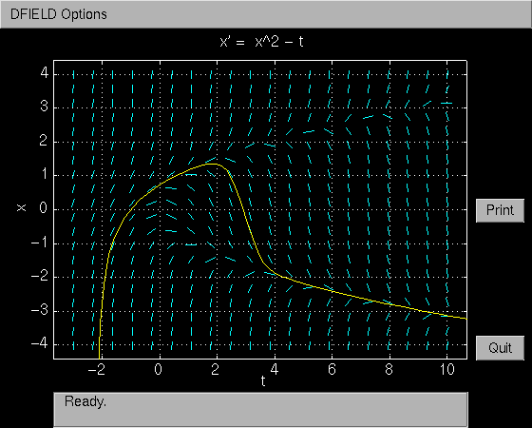

You can also enter the initial conditions via the keyboard by choosing keyboard input under the dfield options menu.

[I:\ARCHIVOS MATLAB\Archivos HTML\DFIELD TUTORIAL_archivos\top.gif](http://www.math.montana.edu/~umsfjdoc/dfieldtut.html#top)

**Options**

Other options are available in the Options menu. These are fairly self explanatory. The Settings option allows the user to change several parameters. Included here are the possibilities of using a vector field instead of the default line field or using no slope lines at all, which is useful if you just want to plot solution curves. You can also erase curves on the graphics window with ''delete a graphics object'' by clicking the mouse on the curve you want to remove.

[I:\ARCHIVOS MATLAB\Archivos HTML\DFIELD TUTORIAL_archivos\top.gif](http://www.math.montana.edu/~umsfjdoc/dfieldtut.html#top)

**Graphing while dfield is open**

This is possible. However there is an problem that arises if you try to plot something while dfield is open. You might end up plotting on one of the two dfield windows, the setup window or the display window. You might want to do the latter. But first if you want a plot on a new window first give the matlab command: figure in the matlab command window (at the matlab prompt):

>>figure

A new window should then come up and this is where the plotting will appear. For example to plot y = sin(t) for t = 0 to 10:

>>t = 0:0.3:10;

>>y = sin(t);

>>plot(t,y);

Here is the result: 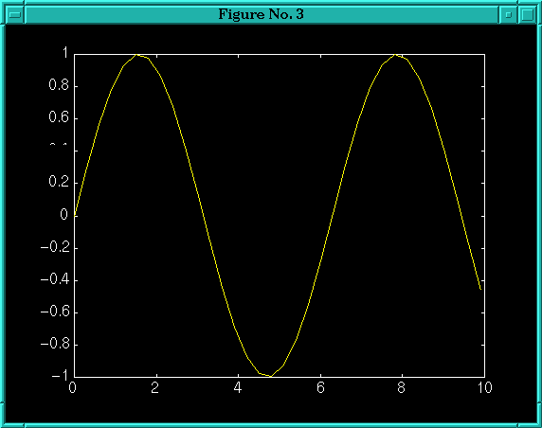

[I:\ARCHIVOS MATLAB\Archivos HTML\DFIELD TUTORIAL_archivos\top.gif](http://www.math.montana.edu/~umsfjdoc/dfieldtut.html#top)

**Graphing on the dfield display window**

Now suppose that you want to plot on the dfield display window. First you nee to tell matlab where you want to plot, you can do this by clicking the mouse on the correct window or by giving the matlab command figure(2), which tells matlab that you want to plot on window 2 which is the dfield display window.

>>figure(2);

Suppose we have the DE y' = y\*(1-0.1\*y) loaded into dfield and we gave dfield the initial condition y(0) = 1 and under Dfield options under settings we told dfield that we didn't want any slope lines or arrows then the display window should look like this:

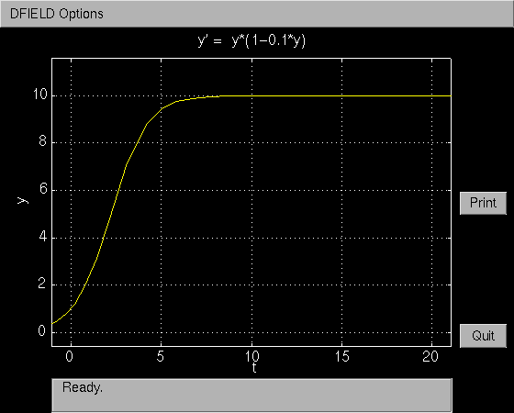

Now lets plot some data on this graph, say t = 0 5 10 15 y = 1 3 6 10:

>>figure(2);

>> t = [ 0 5 10 15];

>> y = [ 1 3 6 10];

>> plot(t,y,'og');

The 'og' plots the data points as (o)hs and in (g)reen. The plot should look like this:

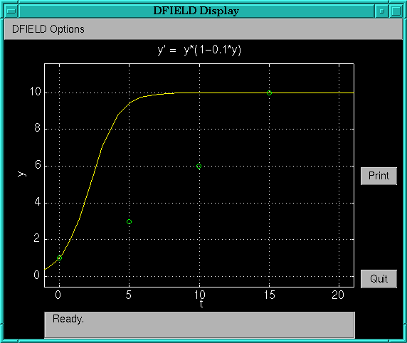

You can get more help on plot in matlab by typing

>>help plot

[I:\ARCHIVOS MATLAB\Archivos HTML\DFIELD TUTORIAL_archivos\top.gif](http://www.math.montana.edu/~umsfjdoc/dfieldtut.html#top)

[Back to M225-02 home page](http://www.math.montana.edu/%7Eumsfjdoc/m225-02.html)